**HOW TO USE GITHUB**

1. **Create a Github account.**
2. **Create a repository:**

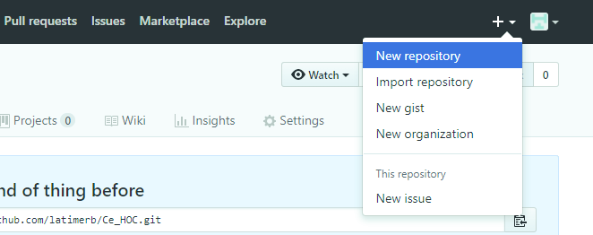

1. **Make a Git repository in the top level directory of the project you want to put on GitHub:**

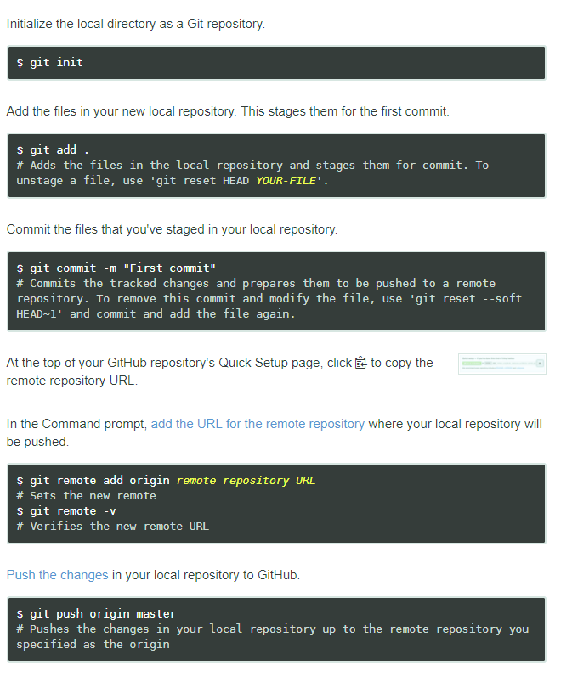

**HOW TO CLONE A REPOSITORY**

